Sprint-4

**Train The Model On IBM**

**Register For IBM Cloud**

|  |  |
| --- | --- |
| TeamID | LTVIP2023TMID07965 |
| ProjectName | Classification of Arrhythmia by Using Deep Learning with 2-D ECG Spectral Image Representation |

TASK:

Register For IBM Cloud:

LOGIN IN IBM CLOUD(SCREEN SHOT):

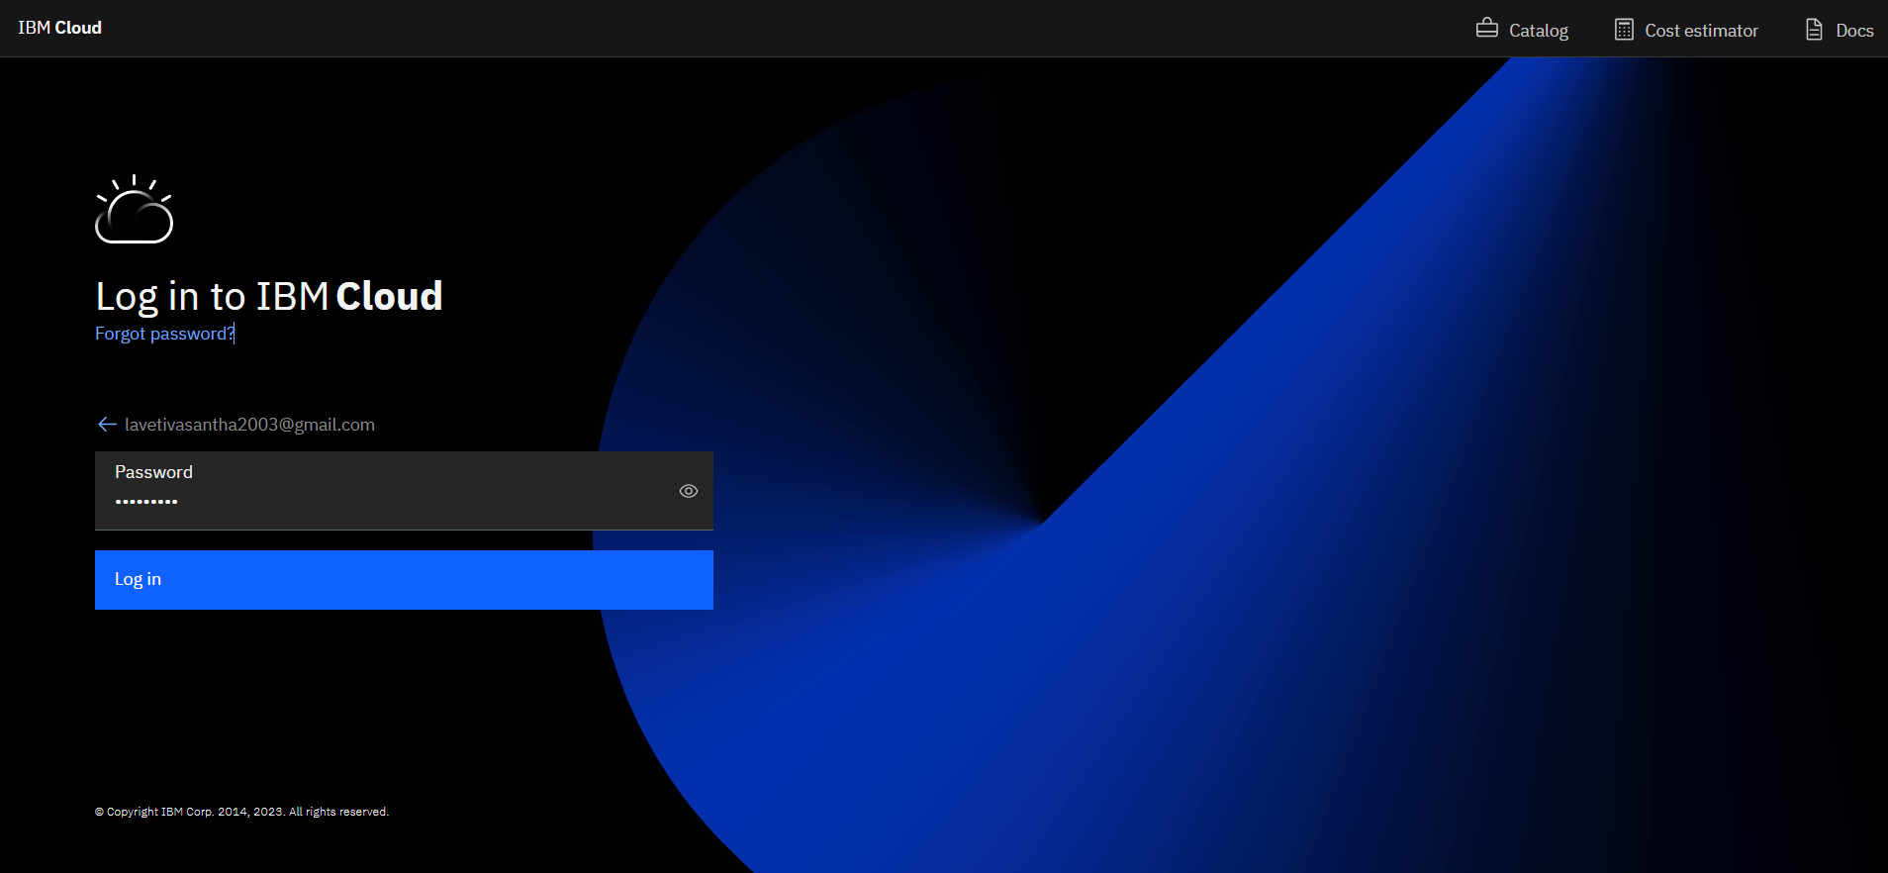

IBM DASHBOARD(SCREEN SHOT):

